R-programming Project

Project: Analysis and Prediction of Airbnb Listing Prices

 1. Data Importing:

#### Import the Airbnb data using readr or other relevant packages. This may include .csv files or other formats

if(!require(pacman)) install.packages("pacman", repos = "[http://cran.us.r-project.org](http://cran.us.r-project.org/)") library(pacman)

pacman::p_load(tidyverse, readr, data.table, caret, lubridate,

ggthemes, ggplot2, glmnet, scales, stringr, dplyr, ggmap, ggcorrplot, treemapify, rpart, nnet, formatR, rmarkdown, knitr)

library(ggmap)

Loading required package: pacman

##  Loading Data:

# Read the Data:

suppressWarnings(airbnb <-read_csv("../input/seattle-airbnb-listings/seattle_01.csv"))

# Set the number of significant digits to 4 options(digits = 4)



── **Column specification ──────────────────────────────────────────────────────── cols(**

**X1 = col_double(), room_id = col_double(), host_id = col_double(),**

**room_type = col_character(), address = col_character(), reviews = col_double(),**

**overall_satisfaction = col_double(), accommodates = col_double(), bedrooms = col_double(),**

**bathrooms = col_double(), price = col_double(),**

**last_modified = col_datetime(format = ""), latitude = col_double(),**

**longitude = col_double(), location = col_character(), name = col_character(), currency = col_character(), rate_type = col_character()**

**)**

2. **Data Cleaning and Transformation:** :

#### Use dplyr and tidyr to clean the data and prepare it for analysis. This may include handling missing values, outliers, or erroneous data.

Transform the data as necessary for analysis. This may include creating new variables, recoding variables, or restructuring the data.

dim(airbnb) str(airbnb)

 7576 · 18

spec_tbl_df [7,576 × 18] (S3: spec_tbl_df/tbl_df/tbl/data.frame)

$ X1 : num [1:7576] 0 1 2 3 4 5 6 7 8 9 ...

$ room_id : num [1:7576] 2318 3335 4291 5682 6606 ...

$ host_id : num [1:7576] 2536 4193 35749 8993 14942 ...

$ room_type : chr [1:7576] "Entire home/apt" "Entire home/apt" "Private r

$ address : chr [1:7576] "Seattle, WA, United States" "Seattle, WA, Uni

$ reviews : num [1:7576] 21 1 63 462 134 130 401 35 36 76 ...

$ overall_satisfaction: num [1:7576] 5 NA 4.5 5 4.5 4.5 5 5 5 4.5 ...

$ accommodates : num [1:7576] 8 4 2 2 2 2 2 4 3 4 ...

$ bedrooms : num [1:7576] 4 2 1 0 1 1 1 2 2 1 ...

$ bathrooms : num [1:7576] 2.5 1 1 1 1 3 1 1 1 1 ...

$ price : num [1:7576] 250 100 82 49 90 65 78 165 95 115 ...

$ last_modified : POSIXct[1:7576], format: "2018-12-20 03:46:14" "2018-12-20

$ latitude : num [1:7576] 47.6 47.5 47.7 47.5 47.7 ...

$ longitude : num [1:7576] -122 -122 -122 -122 -122 ...

$ location : chr [1:7576] "0101000020E6100000D449B6BA9C925EC0416326512FC

$ name : chr [1:7576] "Casa Madrona - Urban Oasis, 1 block from the

$ currency : chr [1:7576] "USD" "USD" "USD" "USD" ...

$ rate_type : chr [1:7576] "nightly" "nightly" "nightly" "nightly" ...

- attr(*, "spec")=

.. cols(

.. X1 = col_double(),

.. room_id = col_double(),

.. host_id = col_double(),

.. room_type = col_character(),

.. address = col_character(),

.. reviews = col_double(),

.. overall_satisfaction = col_double(),

.. accommodates = col_double(),

.. bedrooms = col_double(),

.. bathrooms = col_double(),

.. price = col_double(),

.. last_modified = col_datetime(format = ""),

.. latitude = col_double(),

.. longitude = col_double(),

.. location = col_character(),

.. name = col_character(),

.. currency = col_character(),

.. rate_type = col_character()

.. )

##  Data Cleaning:

#### Storing the dataset into dataframe

airbnb <-as.data.frame(airbnb) class(airbnb)

 'data.frame'

###  Searching NA vlaues

sum(is.na(airbnb))

 1475

###  NA's Values:

colSums(is.na(airbnb))

 X1: 0 room_id: 0 host_id: 0 room_type: 0 address: 0 reviews: 0 overall_satisfaction: 1473 accommodates: 0

bedrooms: 0 bathrooms: 2 price: 0 last_modifled: 0 latitude: 0 longitude: 0 location: 0 name: 0 currency:

0 rate type: 0

#### overall_satisfaction" has 1473 NAs while bathrooms has 2.

na_vis <- data.frame(t(colSums(is.na(airbnb))))

na_bar <- data.frame(Features = names(na_vis),totals=colSums(na_vis))

###  Visulaization of NA's Values:

na_bar %>% ggplot(aes(x = reorder(Features, totals), y = totals, fill = Features, label = totals))+ geom_bar(stat = "identity")+

ggtitle("NA Distribution")+ xlab("Features")+ ylab("Total NAs")+ coord_flip()+

geom_text(size = 3, position = position_stack(vjust = 0.5))+ theme_bw()+

theme(plot.title = element_text(hjust = 0.5))

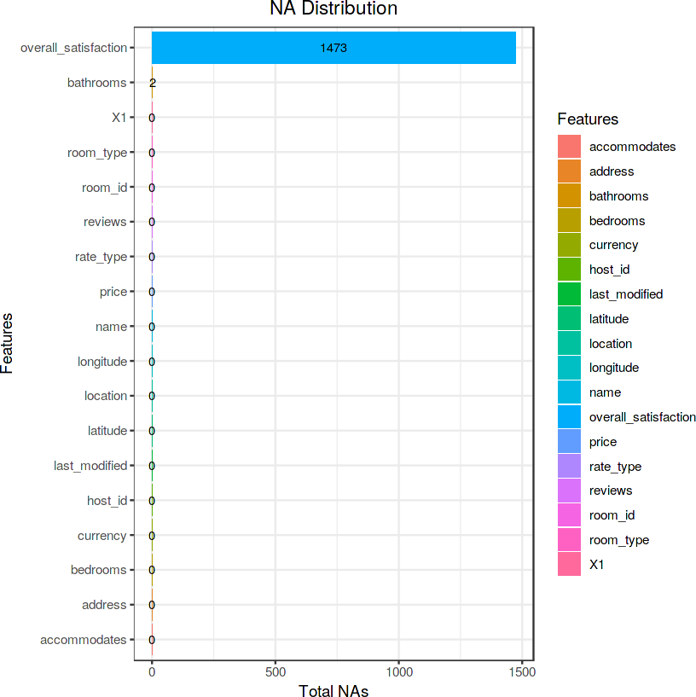

Only overall_satisfaction & bathrooms has NA's value

##  NA Removal:

airbnb$overall_satisfaction[is.na(airbnb$overall_satisfaction)] <- mean(airbnb$overall_satisfaction, na.rm = TRUE)

#### The mean is roughly 4.84.

mean(airbnb$overall_satisfaction)

4.84122562674095

#### Confirm the absence of NAs in this feature:

head(airbnb$overall_satisfaction)

5 · 4.84122562674095 · 4.5 · 5 · 4.5 · 4.5

#### For the bathrooms feature, there are only 2 NAs and so we set them to zero.

airbnb <-airbnb %>% replace_na(list(bathrooms = 0))

#### Now confirm the absence of any NAs in the dataset:

sum(is.na(airbnb))

 0

##  Feature Exploration and Selection:

names(airbnb)

 'X1' · 'room_id' · 'host_id' · 'room_type' · 'address' · 'reviews' · 'overall_satisfaction' · 'accommodates' · 'bedrooms' · 'bathrooms' · 'price' · 'last modified' · 'latitude' · 'longitude' · 'location' · 'name' · 'currency' ·

#### There are 18 features and those less related to price prediction will be dropped to refine our EDA and Modeling Focus:

head(airbnb$X1)

0 · 1 · 2 · 3 · 4 · 5

"X1" is simply a numerical list for the dataset.

###  Features: "room_id" & "host_id"

head(airbnb$room_id) head(airbnb$host_id)

 2318 · 3335 · 4291 · 5682 · 6606 · 9419

2536 · 4193 · 35749 · 8993 · 14942 · 30559

"room_id" & "host_id" are simply numbers arbitrarily assigned to identify rooms and hosts.

###  Feature: "address"

#### Check for unique values of the feature "address"

airbnb %>% select(address) %>% distinct()

A data.frame: 27 × 1

**address**

**<chr>** Seattle, WA, United States Kirkland, WA, United States Bellevue, WA, United States Redmond, WA, United States Mercer Island, WA, United States

Seattle, WA Renton, WA, United States Ballard, Seattle, WA, United States West Seattle, WA, United States Medina, WA, United States

西雅图, WA, United States

Newcastle, WA, United States Seattle , WA, United States Ballard Seattle, WA, United States Yarrow Point, WA, United States Clyde Hill, WA, United States Tukwila, WA, United States

Seattle, Washington, US, WA, United States Capitol Hill, Seattle, WA, United States Kirkland , Wa, United States

Hunts Point, WA, United States Seattle, DC, United States Seattle, United States Vashon, WA, United States Kirkland , WA, United States Bothell, WA, United States

Washington, WA, United States

#### Note that there are 27 values with different formats and 12 repeated instances of "Seattle." Any neighborhood of Seattle, the Chinese language version of "Seattle" and listings with only the State of Washington, will all be converted to Seattle. "WA" and "United States" will also be removed as they are redundant.

address_clean <-gsub("Seattle, WA, United States", "Seattle", gsub("Kirkland, WA, United States", "Kirkland", gsub("Bellevue, WA, United States", "Bellevue", gsub("Redmond, WA, United States", "Redmond",

gsub("Mercer Island, WA, United States", "Mercer Island", gsub("Seattle, WA", "Seattle",

gsub("Renton, WA, United States", "Renton", gsub("Ballard, Seattle, WA, United States", "Seattle", gsub("West Seattle, WA, United States", "Seattle", gsub("Medina, WA, United States", "Medina", gsub("Newcastle, WA, United States", "Newcastle", gsub("Seattle , WA, United States", "Seattle", gsub("Ballard Seattle, WA, United States", "Seattle", gsub("Yarrow Point, WA, United States", "Yarrow Point", gsub("Clyde Hill, WA, United States", "Clyde Hill", gsub("Tukwila, WA, United States", "Tukwila",

gsub("Seattle, Washington, US, WA, United States", "Seattle", gsub("Capitol Hill, Seattle, WA, United States", "Seattle", gsub("Kirkland , Wa, United States", "Kirkland",

gsub("Hunts Point, WA, United States", "Hunts Point", gsub("Seattle, DC, United States", "Seattle", gsub("Seattle, United States", "Seattle", gsub("Vashon, WA, United States", "Vashon", gsub("Kirkland , WA, United States", "Kirkland", gsub("Bothell, WA, United States", "Bothell", gsub("Washington, WA, United States", "Seattle",

airbnb$address))))))))))))))))))))))))))

#### Replace the Chinese version of "Seattle" separately using regex:

address_clean2 <-gsub(".*WA*.", "Seattle", address_clean)

#### Reassign the column to the feature "address":

airbnb$address <-gsub("Seattle, United States", "Seattle",

gsub("Seattle United States", "Seattle", address_clean2))

#### Now confirm there are only 14 different cities and sort by the greatest numbers of listings:

city_list <-airbnb %>% group_by(address) %>% summarize(listing_sum = n()) %>% arrange(-listing_sum)

city_list

A tibble: 14 × 2

|  |  |
| --- | --- |
| **address**  **<chr>** | **listing_sum**  **<int>** |
| Seattle | 6791 |
| Bellevue | 322 |
| Kirkland | 202 |
| Redmond | 110 |
| Mercer Island | 50 |
| Newcastle | 49 |
| Renton | 39 |
| Medina | 4 |
| Bothell | 2 |
| Clyde Hill | 2 |
| Yarrow Point | 2 |
| Hunts Point | 1 |
| Tukwila | 1 |
| Vashon | 1 |

 : Let's explore a data visualization to confirm this:

#### Note: As the remaining locations are all cities, the feature "address" will later be renamed "city."

city_list %>%

ggplot(aes(x = reorder(address, listing_sum), y = listing_sum,

fill = address, label = listing_sum))+ geom_bar(stat = "identity")+ ggtitle("Location Distribution")+ xlab("Location")+

ylab("Total Listings")+ coord_flip()+ geom_text(size = 4,

position = position_stack(vjust = 0.5))+ theme_bw()+

theme(plot.title = element_text(hjust = 0.5))

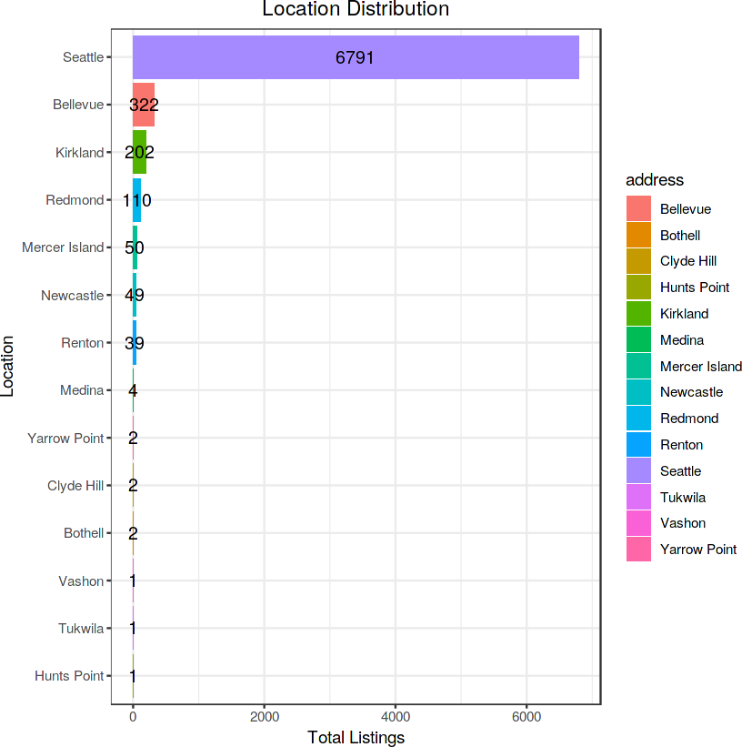

#### It is clear the vast majority of listings are in Seattle (6791).

head(airbnb$last_modified)

 [1] "2018-12-20 03:46:14 UTC" "2018-12-20 04:08:45 UTC"

[3] "2018-12-20 03:04:19 UTC" "2018-12-20 04:11:25 UTC"

[5] "2018-12-20 03:12:38 UTC" "2018-12-20 04:08:20 UTC"

###  Feature: "location"

The "location" feature will be removed in favor of using "latitude" & "longitude."

head(airbnb$location)

###  Feature: "name"

#### The "name" feature will be removed as it is a categorical description of each listing.

head(airbnb$name)

 'Casa Madrona - Urban Oasis, 1 block from the Park!' · 'Sweet Seattle Urban Homestead 2 Bdr' · 'Sunrise in Seattle Master Suite' · 'Cozy Studio min to downtown -WiFi' ·

###  Feature: "currency"

#### The "currency" feature will be dropped as all rates are in US Dollars.

airbnb %>% select(currency) %>% distinct()

 A

data.frame: 1 × 1

**currency**

**<chr>**

USD

###  Feature: "rate_type"

#### Check for distinct values of "rate_type":

airbnb %>% select(rate_type) %>% distinct()

 A

data.frame: 1

× 1

**rate_type**

**<chr>**

nightly

After confirming only one unique value, "nightly," we determine this feature can be removed.

##  Create the cleaned dataset:

#### Remove the above mentioned features and rename the columns:

airbnb <-airbnb %>% select(-c(X1, room_id, host_id, last_modified,

location, name, currency, rate_type)) %>% rename(city = address, rating = overall_satisfaction,

reviews_sum = reviews)

#### Reorder the columns:

airbnb <-airbnb[,c(8, 2, 4, 3, 1, 6, 7, 5, 9, 10)]

#### Confirm the features have been tidied and reordered with only 10 features:

names(airbnb)

 'price' · 'city' · 'rating' · 'reviews_sum' · 'room_type' · 'bedrooms' · 'bathrooms' · 'accommodates' · 'latitude' · 'longitude'

#### Check the first few values of the cleaned dataset:

head(airbnb)

A data.frame: 6 × 10

|  |  |  |  |  |  |  |  |  |  |
| --- | --- | --- | --- | --- | --- | --- | --- | --- | --- |
| **price**  **<dbl>** | **city**  **<chr>** | **rating**  **<dbl>** | **reviews_sum**  **<dbl>** | **room_type**  **<chr>** | **bedrooms**  **<dbl>** | **bathrooms**  **<dbl>** | **accommodates**  **<dbl>** | **latitude**  **<dbl>** | **longitude**  **<dbl>** |
| **1** 250 | Seattle | 5.000 | 21 | Entire home/apt | 4 | 2.5 | 8 | 47.61 | -122.3 |
| **2** 100 | Seattle | 4.841 | 1 | Entire home/apt | 2 | 1.0 | 4 | 47.53 | -122.3 |
| **3** 82 | Seattle | 4.500 | 63 | Private room | 1 | 1.0 | 2 | 47.69 | -122.3 |
| **4** 49 | Seattle | 5.000 | 462 | Entire home/apt | 0 | 1.0 | 2 | 47.52 | -122.4 |
| **5** 90 | Seattle | 4.500 | 134 | Entire home/apt | 1 | 1.0 | 2 | 47.65 | -122.3 |
| **6** 65 | Seattle | 4.500 | 130 | Private room | 1 | 3.0 | 2 | 47.55 | -122.3 |

#  3. Exploratory Data Analysis:

Use various R functions and packages to explore the data. This can include summary statistics, correlations, and distributions. Create visualizations using R's plotting capabilities. This can include scatter plots, boxplots, histograms, etc.

### Correlogram:

#### Remove non-numeric features:

airbnb_num <-airbnb %>% select(-c(city, room_type))

#### Create the correlation matrix:

airbnb_cor <-cor(airbnb_num)

#### Plot the Correlogram:

ggcorrplot(airbnb_cor)+

labs(title = "Airbnb Correlogram")+ theme(plot.title = element_text(hjust = 0.5))

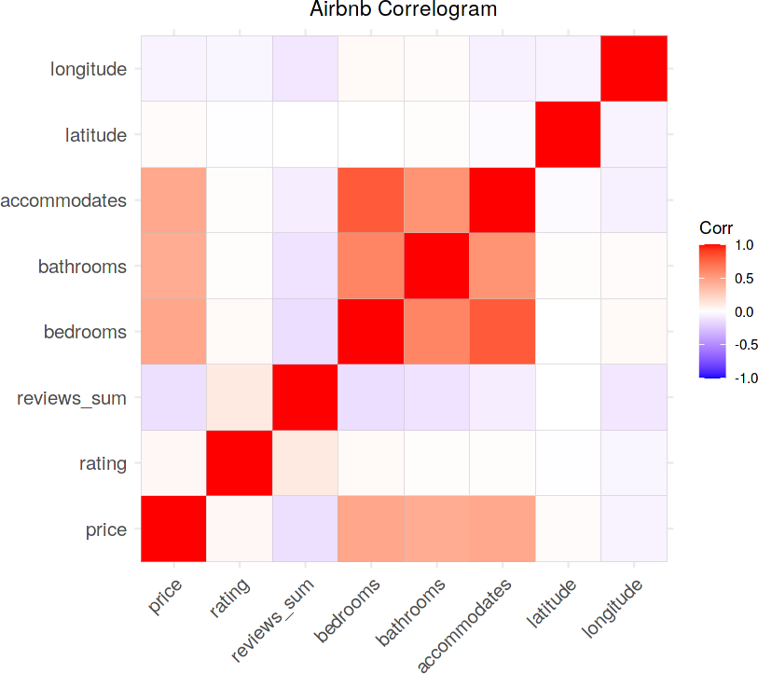

###  Density Plot of Price Distribution below $300:

#### Most common Price of bookings

airbnb %>% filter(price <=300) %>% ggplot(aes(price))+

geom_density(fill = "deepskyblue", size = 1.5, color = "navyblue", alpha = 0.5)+ xlab("Price")+

ylab("Density")+

ggtitle("Price Distribution at or Below $300")+ theme(plot.title = element_text(hjust = 0.5))

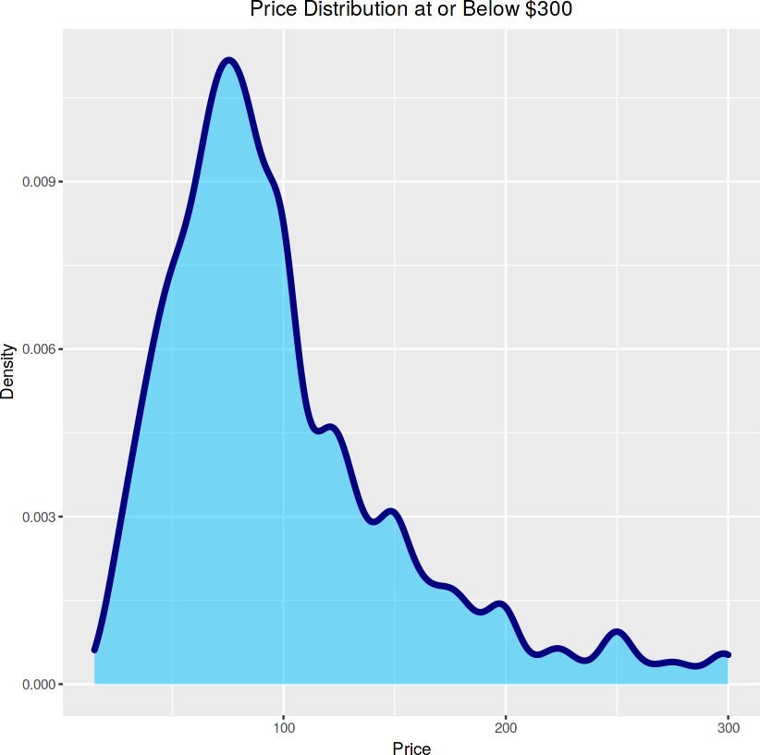

The most common booking price is $100/night.

###  Geographical Scatterplot of Prices in Seattle:

#### Which area are more expensive than others

seattle_map <- get_stamenmap(bbox = c(left = -122.5, bottom = 47.49,

right = -122.09, top = 47.74), zoom = 9, maptype = "toner")

summary(airbnb$price)



|  |  |  |
| --- | --- | --- |
| Min. 1st Qu. Median | Mean 3rd Qu. | Max. |
| 15 65 88 | 113 125 | 5900 |

#### Ad per visulaization Summary, we know what percentage of prices are less than or equal to 300.

quantile(airbnb$price)

sum(airbnb$price <=300)/length(airbnb$price)

 0%: 15 25%: 65 50%: 88 75%: 125 100%: 5900

0.965153115100317

airbnb_map <-airbnb %>% filter(price <=300)

###  Visualizing a "Heatmap" of Seattle with all listing prices included:

ggmap(seattle_map, extent= "normal")+ geom_point(data = airbnb,

aes(x = longitude, y = latitude, color = price), size = 1.5, alpha = .6)+

scale_color_gradientn(colors = c("mediumblue", "lawngreen", "blueviolet", "red"), values = scales::rescale(c(.003, .013, .0176, .025, .2, .3, .4)))+

xlab("Longitude")+ ylab("Latitude")+

ggtitle("Seattle Location Pricing")+ theme(plot.title = element_text(hjust = 0.5),

panel.border = element_rect(color = "gray", fill=NA, size=3))

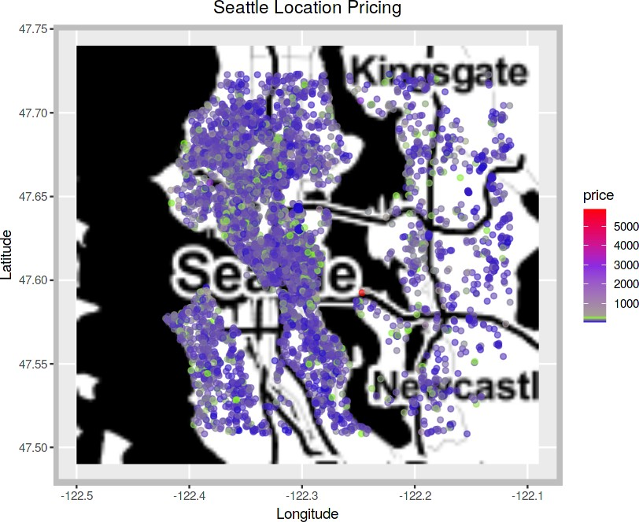

It seems no area is significantly pricier than others, with most prices under $1000. Outliers might be skewing the data, so let's refine our heatmap by filtering it.

###  Heat Map of less than or equal to $300

ggmap(seattle_map, extent= "normal")+ geom_point(data = airbnb_map,

aes(x = longitude, y = latitude, color = price), size = 1.5, alpha = .6)+

scale_color_gradientn(colours = rainbow(5))+ xlab("Longitude")+

ylab("Latitude")+

ggtitle("Seattle Pricing at or Below $300")+ theme(plot.title = element_text(hjust = 0.5),

panel.border = element_rect(color = "gray", fill=NA, size=3))

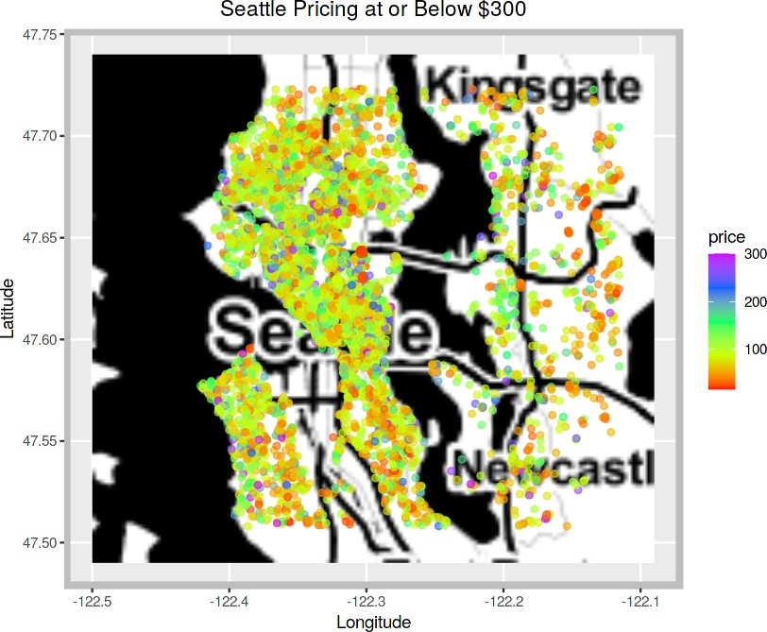

#### The visualization shows most Seattle listings are between 50*and*150 per night, concentrated in Seattle proper. Confirm the percentage of listings in this range.

sum(airbnb$price >= 50 & airbnb$price <= 150)/length(airbnb$price)

0.699841605068638

70% of are in range from USD 50 - 150/night.

##  Treemap:

#### Sort the cities by listing_sum in a dataframe for the Treemap. Plot the Treemap to visualize the distribution of listings by city.

city_distribution <-airbnb %>% group_by(city) %>% summarize(listing_sum = n()) %>% arrange(-listing_sum)

# Add column "tmlab" for Treemap labels city_distribution <-city_distribution %>%

unite("tmlab", city:listing_sum, sep = " ", remove = FALSE)

# Plot a Treemap to visualize the distribution of listings by city: city_distribution %>% ggplot(aes(area = listing_sum, fill = city, label = tmlab))+

geom_treemap()+

geom_treemap_text(fontface = "italic", col = "white", place = "center", grow = TRUE)

 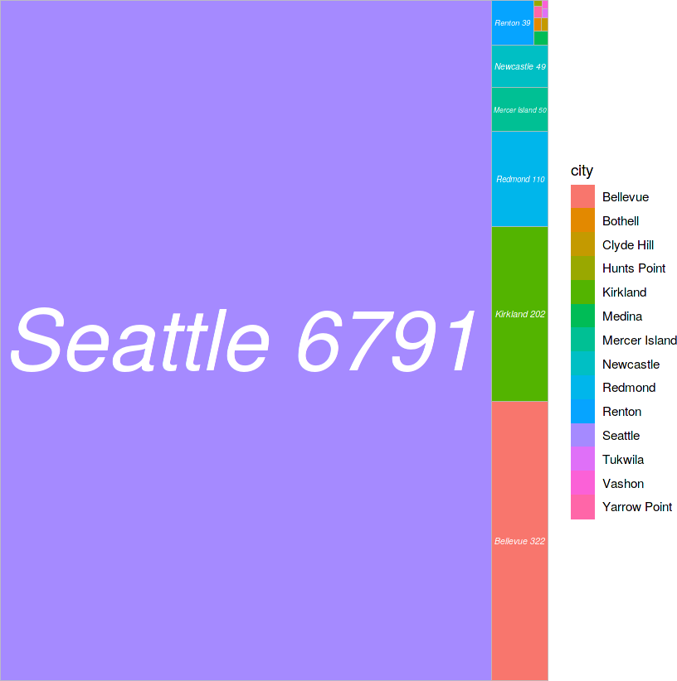

###  Visualize Price by City:

city_price <-airbnb %>% group_by(city) %>% summarize(mean_price = mean(price),

listing_sum = n()) %>%

arrange(-mean_price) %>% mutate(mean_price = sprintf("%0.1f", mean_price)) # Coerce the "mean_price" to integer:

city_price$mean_price <-as.integer(city_price$mean_price)

#### Plot the Visualization:

city_price %>% ggplot(aes(x = reorder(city, mean_price), y = mean_price,

fill = city, label = mean_price))+ geom_bar(stat = "identity")+

coord_flip()+ xlab("City")+ ylab("Mean Price")+

ggtitle("Mean Price per Night by City")+ geom_text(size = 4,

position = position_stack(vjust = 0.5))+ theme_bw()+

theme(plot.title = element_text(hjust = 0.5))

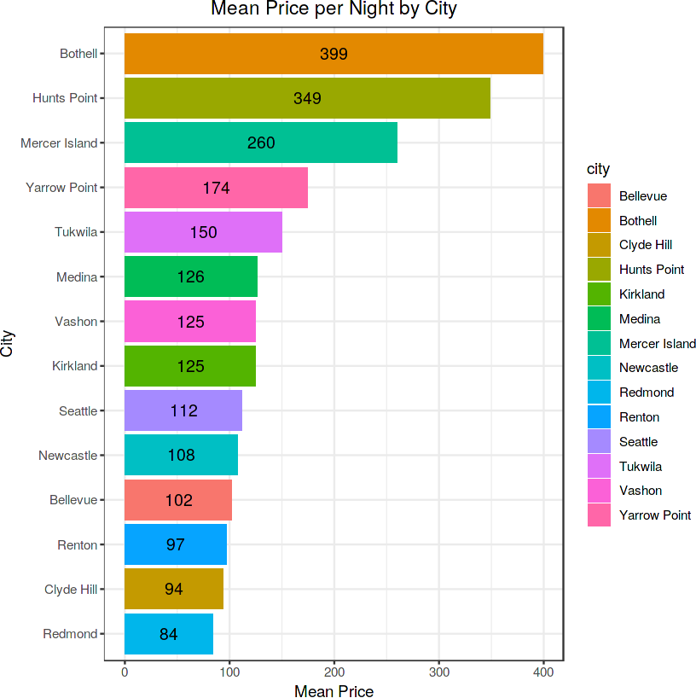

###  Visualize Mean Price & Sum of Listings by City:

# Create dataframe "city_comp" with a percentage column: city_comp <-city_price %>%

mutate(percentage = sprintf("%0.3f",(listing_sum/sum(listing_sum)*100))) # Add the % symbol to the percentage feature:

city_comp$percentage <- paste(city_comp$percentage, "%")

# Combine the mean price & percentage values into one column: city_comp <-city_comp %>%

unite("citylab", mean_price, percentage, sep = ", ", remove = FALSE)

#### Plot the visualization with Mean Price & Percentage of Total Listings:

city_comp %>%

ggplot(aes(x = reorder(city, mean_price), y = mean_price,

fill = city, label = citylab))+ geom_bar(stat = "identity")+

coord_flip()+ xlab("City")+ ylab("Mean Price")+

ggtitle("Mean Price & Percentage of Total Listings by City")+ geom_text(size = 3, position = position_stack(vjust = 0.5))+ theme_bw()+

theme(plot.title = element_text(hjust = 0.5))

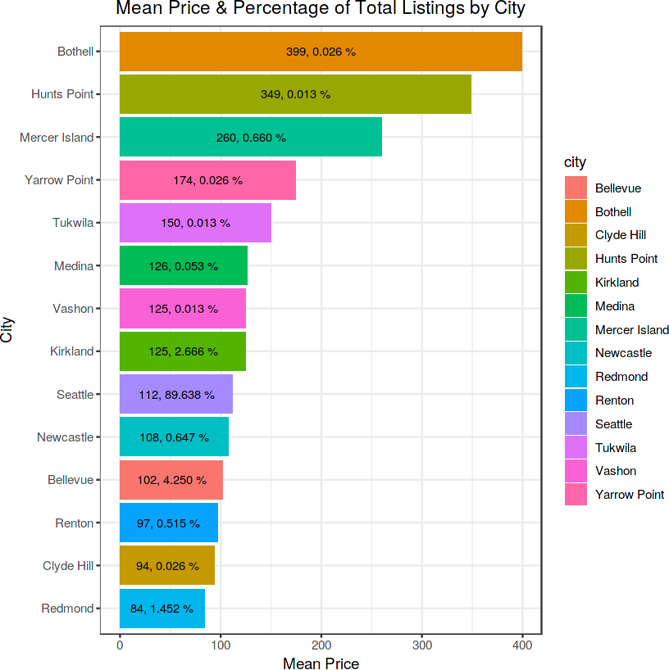

Over 89% of listings are in Seattle with an average price of 112*pernight*. *Thetop*7*highestaverage* − *pricedlistingsmakeupabout*0.8

226.10 per night. This lower percentage of high-priced listings and the concentration of nearly 90% in Seattle explains the lower correlation between price and location.

#  4. Feature Engineering:

Engineer new features from the existing ones that may be useful for the prediction task. For example, one might use the latitude and longitude data to create a new feature that represents the distance from a popular landmark.

###  Feature: "rating"

#### The "rating" feature ranges from 0 to 5, with a mean of 4.841. To explore its relationship with mean price by city for price prediction, create the rating_comp dataframe to compare mean price and rating. Set parameters for a dual-axis plot, then plot a bar chart for ratings with an overlapping red line for price.

rating_comp <-airbnb %>% group_by(city) %>%

summarize(mean_rating = mean(rating), mean_price = mean(price)) %>% select(city, mean_rating, mean_price)

# Set the parameters for the dual-axis plot:

ylim_1 <-c(0,10) ylim_2 <-c(70, 400)

b <- diff(ylim_1)/diff(ylim_2) a <- b*(ylim_1[1] - ylim_2[1])

# Plot the Barplot (Rating) with Overlapping Line (Price): ggplot(rating_comp, aes(city, group =1))+

geom_bar(aes(y=mean_rating), stat="identity", color = "navyblue", alpha=.7)+ geom_line(aes(y = a + mean_price*b), color = "red", size = 2)+ scale_y_continuous(name = "Mean Rating",

sec.axis = sec_axis(~ (. - a)/b, name = "Mean Price"))+

xlab("City")+

ggtitle("Rating & Price Comparison by City")+ theme(axis.text.x = element_text(angle = 45, hjust=1),

plot.title = element_text(hjust = 0.5))

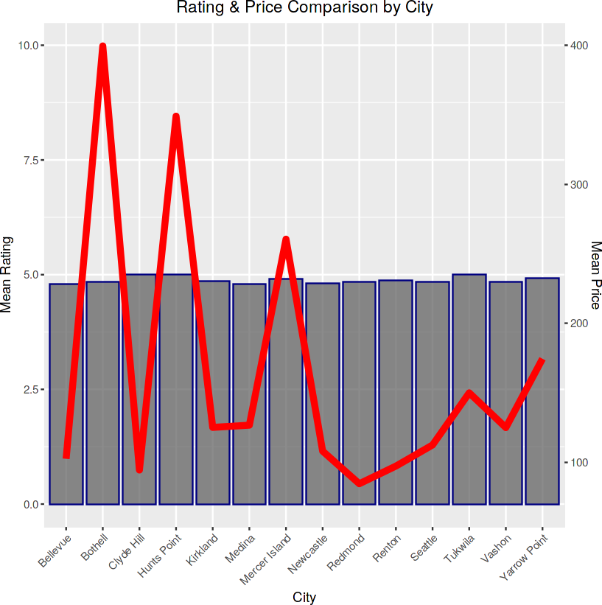

range(rating_comp$mean_rating)

4.79561281337047 · 5

Due to the narrow range of mean ratings by city, there's a low correlation between price and rating. For instance, high prices don't ensure higher ratings; Bothell, the most expensive city, doesn't have the highest rating. Additionally, cities with lower average prices often have higher mean ratings than Bothell.

###  Feature: "reviews_sum"

#### compare the total number of reviews and different price ranges:

airbnb %>% filter(price <= 1000) %>% ggplot(aes(x = reviews_sum, y = price))+

geom_point(color="navyblue", alpha = 0.6, size = 1.5)+ xlab("Number of Reviews")+

ylab("Price")+

ggtitle("Review vs Price Distribution")+ theme_bw()+

theme(plot.title = element_text(hjust = 0.5))

 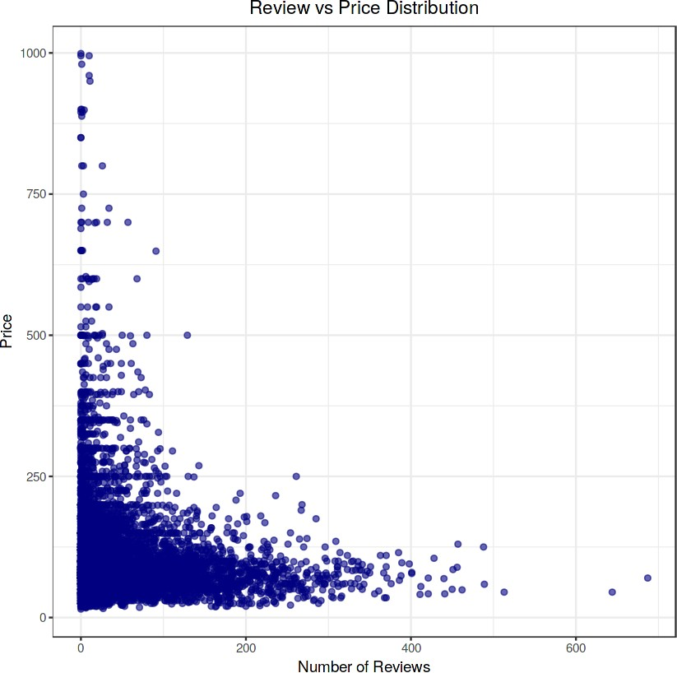

The visualization indicates that listings with higher prices (above ~$500) generally have fewer reviews, likely due to fewer stays at these prices.

###  Feature: "room_type"

#### There are 3 room types: Entire home/apartment, Private Room, and Shared Room. Let's explore the relationship between room type and average price.

airbnb %>% group_by(room_type) %>% summarize(mean_price = mean(price)) %>% ggplot(aes(reorder(room_type, mean_price),

y = mean_price, label=sprintf("%0.2f",

round(mean_price, digits = 2))))+ geom_bar(stat = "identity", color = "navyblue",

size = 1.5, fill = "deepskyblue")+ coord_flip()+

xlab("Room Type")+ ylab("Mean Price")+

ggtitle("Mean Price by Room Type")+ geom_text(size = 3,

position = position_stack(vjust = 0.5))+ theme_bw()+

theme(plot.title = element_text(hjust = 0.5))

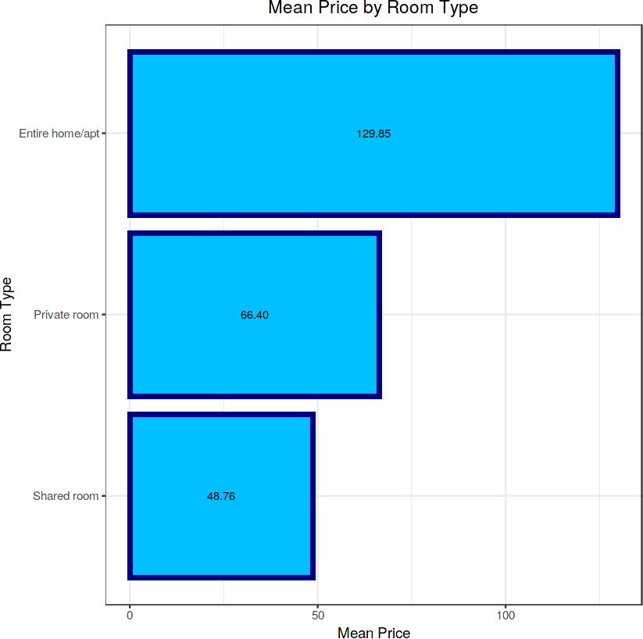

###  Feature: "bathrooms"

#### Bathrooms range from 0 to 8 in increments of 0.5 per listing. Let's create a visualization to show the mean price per listing based on the number of bathrooms available.

airbnb %>% group_by(bathrooms) %>% summarize(mean_price = mean(price)) %>% ggplot(aes(bathrooms, mean price))+

geom_bar(stat = "identity", fill = "deepskyblue", color = "navyblue", size = 1.2)+ xlab("Number of Bathrooms")+

ylab("Mean Price per Night")+

ggtitle("Mean Price per Number of Bathrooms")+ theme_bw()+

theme(plot.title = element_text(hjust = 0.5))

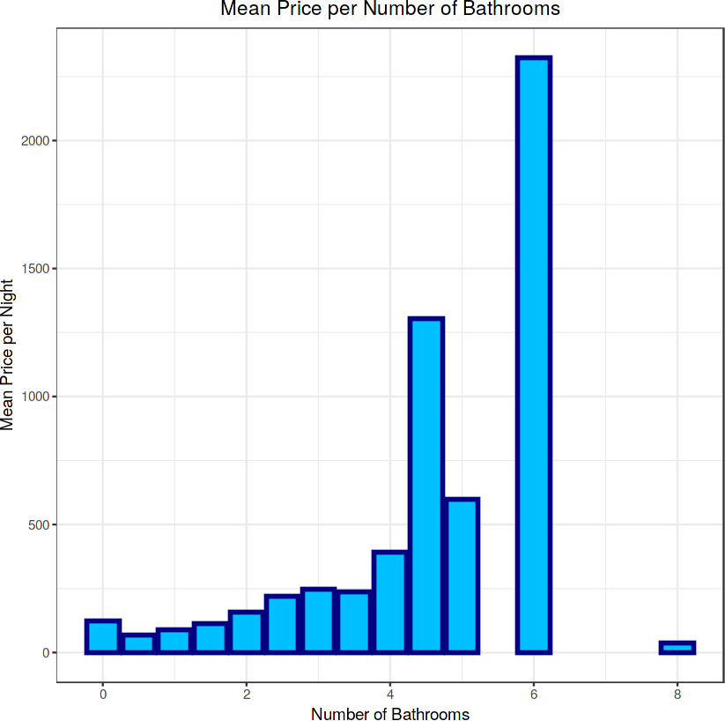

#### We observe that typically, higher numbers of bathrooms per listing correlate with higher prices. Interestingly, listings with 0 bathrooms had a higher average price than those with 0.5 to 1.5 bathrooms and even 8 bathrooms. This suggests that a listing with 8 bathrooms having a lower mean price than one with only one bathroom is likely an outlier.

Now, let's create a bar plot to visualize the total number of listings per bathroom count.

airbnb %>% group_by(bathrooms) %>% summarize(sum_bath = length(bathrooms)) %>% ggplot(aes(reorder(bathrooms, sum_bath), y=sum_bath, label = sum_bath))+ geom_bar(stat = "identity", fill = "deepskyblue", color = "cyan", size = 1.2)+ coord_flip()+

geom_text(size = 5, color = "navyblue",

position = position_stack(vjust = 0.5))+ xlab("Number of Bathrooms")+

ylab("Total Number of Listings")+ ggtitle("Listing Distribution by Bathroom Total")+ theme_bw()+

theme(plot.title = element_text(hjust = 0.5))

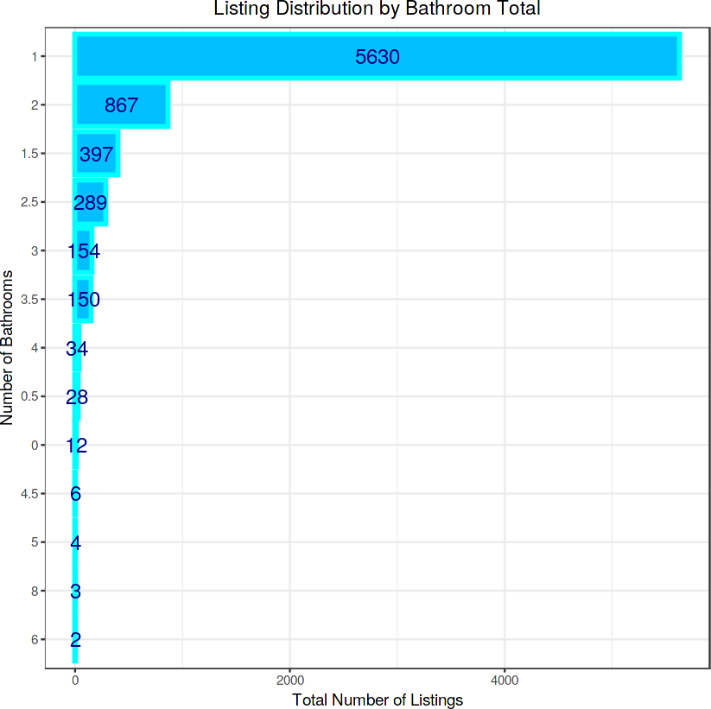

#### It's clear that the majority of listings, approximately 74%, have only 1 bathroom.

It seems like there might be a slight confusion in your request. You mentioned exploring the relationship between mean price per listing and the number of bedrooms, but then referred to beds. Could you please confirm whether you meant to explore the relationship between mean price per listing and the number of bedrooms or the number of beds?

airbnb %>% group_by(bedrooms) %>% summarize(mean_price = mean(price)) %>% ggplot(aes(bedrooms, mean_price))+ geom_bar(stat = "identity",

color = "navyblue", fill = "deepskyblue", size = 1.5)+ xlab("Number of Bedrooms")+

ylab("Mean Price per Night")+

ggtitle("Mean Price Distribution by Bedroom Total")+ theme_bw()+

theme(plot.title = element_text(hjust = 0.5))

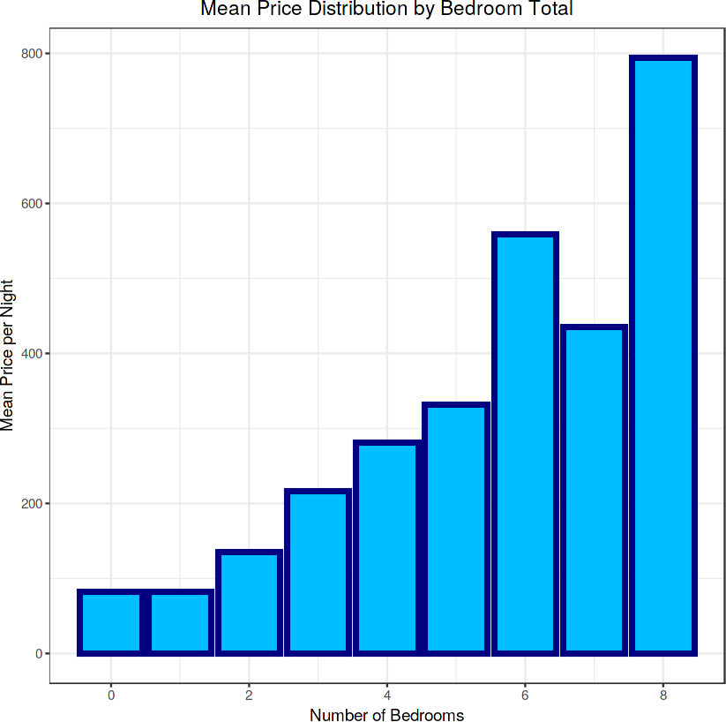

#### The visualization confirms a moderately positive correlation between price and the number of bedrooms. This feature is likely to significantly contribute to the accuracy of our price prediction models.

Now, let's explore the distribution of listings by the number of bedrooms.

airbnb %>% group_by(bedrooms) %>% summarize(sum_beds = length(bedrooms)) %>% ggplot(aes(reorder(bedrooms, sum_beds), y = sum_beds, label = sum_beds))+ geom_bar(stat = "identity",

color = "cyan", fill = "deepskyblue", size = 1.5)+ coord_flip()+

geom_text(size = 5, color = "navyblue",

position = position_stack(vjust = 0.5))+ xlab("Total Number of Listings")+

ylab("Listing Distribution by Bedroom Total")+ ggtitle("Number of Bedrooms")+

theme_bw()+

theme(plot.title = element_text(hjust = 0.5))

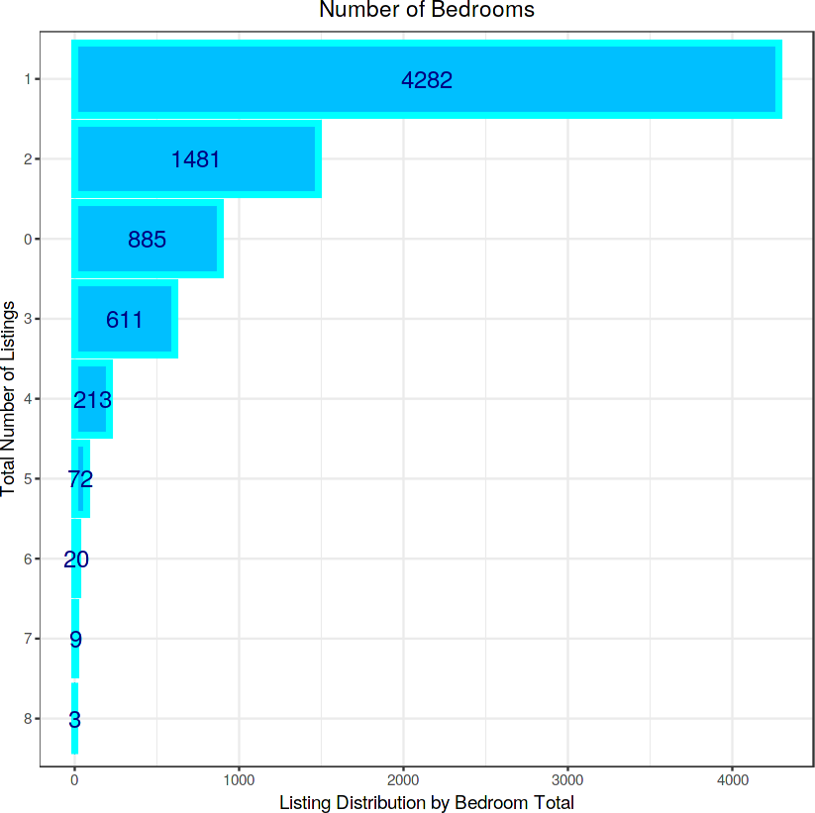

1-bedroom listings lead the distribution with 4,282 listings (56.5%). Based on these findings, there's a high probability that guests will rent a 1- bedroom, 1-bath unit.

###  Feature: "accommodates"

#### Typically, we might predict that the mean price per night of a listing would increase with the number of guests it can accommodate. Let's visualize this relationship.

airbnb %>% group_by(accommodates) %>% summarize(mean_price = mean(price)) %>% ggplot(aes(accommodates, mean_price))+

geom_bar(stat = "identity", color = "navyblue", size = 2, fill = "deepskyblue")+

xlab("Accommodates")+ ylab("Mean Price")+

ggtitle("Number of Guests Accommodated & Mean Price")+ theme_bw()+

theme(plot.title = element_text(hjust = 0.5))

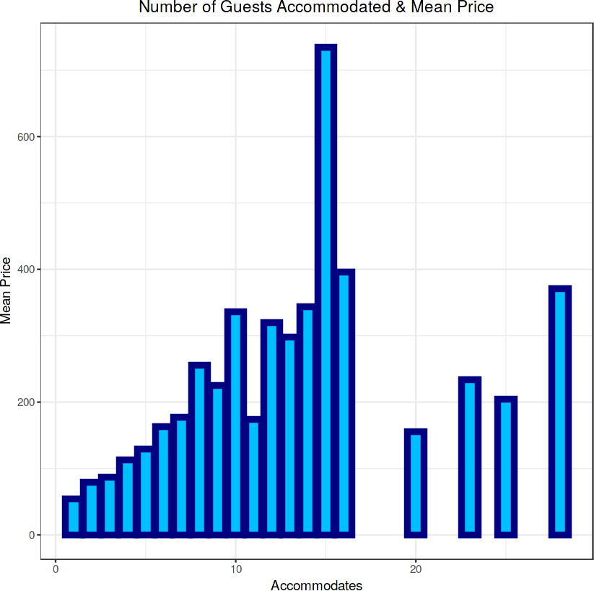

#### The visualization confirms that there is a general increase in average price as the number of guests a listing can accommodate increases. Finally, let's examine the distribution of listings based on the maximum number of guests they can accommodate.

airbnb %>% group_by(accommodates) %>% summarize(sum_acc = length(accommodates)) %>% ggplot(aes(x = factor(accommodates), y = sum_acc))+

geom_bar(stat = "identity", color = "navyblue", fill = "deepskyblue", size = 1.5)+ xlab("Number of Guests Accommodated")+

ylab("Total Number of Listings")+ ggtitle("Listings Sum by Accommodation Total")+ theme_bw()+

theme(plot.title = element_text(hjust = 0.5))

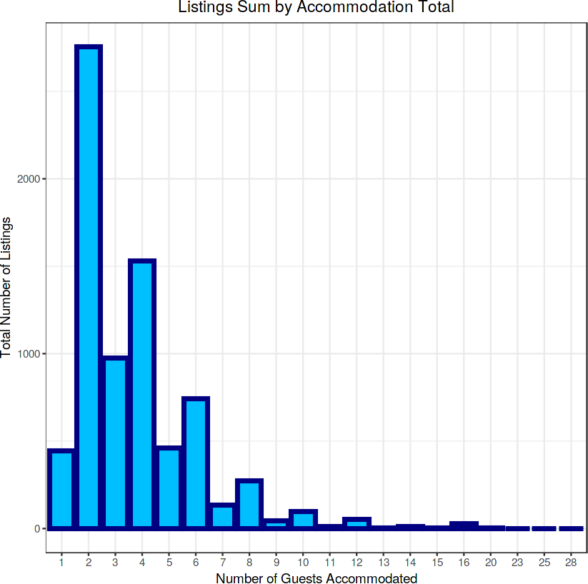

#### The majority of listings can accommodate 4 or fewer guests, with 2 guests being the most popular option.

EDA Conclusion: The correlogram initially highlights significant relationships between price, bedrooms, bathrooms, and accommodation capacity, which were later confirmed through visualizations and quantitative analysis. Additionally, features like location (using latitude and longitude), rating, and review count show potential to enhance predictive model accuracy if included in our formula. "Room_type," although crucial, may need to be transformed into a quantitative scale for regression models, an aspect we will revisit in our conclusion.

 5. **Modeling:**

Split the data into a training set and a testing set.

Build a regression model (or other appropriate model) to predict the price of a listing. Consider multiple different types of models, and evaluate their performance.

Include the visualization of these models using R's capabilities.

# Set the seed for reproducibility:

set.seed(123, sample.kind = "Rounding")

test_index <- createDataPartition(y = airbnb$price, times = 1, p = 0.1, list = F) airbnb_combined <- airbnb[-test_index,]

airbnb_test <- airbnb[test_index,] # Remove test_index:

rm(test_index)

 Warning message in set.seed(123, sample.kind = "Rounding"): “non-uniform 'Rounding' sampler used”

#### splits airbnb_combined into airbnb_train (80%) and airbnb_validation (20%) using a specified random seed (random_state=42) for consistency in results. Adjust the random_state parameter for different randomization

RMSE <-function(true_ratings, predicted_ratings){ sqrt(mean((true_ratings - predicted_ratings)^2))

}

###  The Loss Function / RMSE

#### The Root Mean Square Error (RMSE) calculates the square root of the average squared differences between predicted and actual values in the test set. RMSE is preferred in regression models because it penalizes larger errors more significantly, making it a suitable metric when minimizing large errors is crucial.

Mathematically, it is defined as:

∑(*yu*,*i* − *yu*,*i* )2 *N u*,*i*

√

1

RMSE <-function(true_ratings, predicted_ratings){ sqrt(mean((true_ratings - predicted_ratings)^2))

}

airbnb_train_median <-median(airbnb_train$price)

 6. **Model Evaluation:**

#### Evaluate the model using appropriate metrics and techniques. This can include RMSE, etc. Interpret the model results and document findings.

MM_RMSE <-RMSE(validation$price, airbnb_train_median) results_table <-tibble(Model_Type = "Baseline Median",

RMSE = MM_RMSE) %>%

mutate(RMSE = sprintf("%0.2f", RMSE)) knitr::kable(results_table)



|Model_Type |RMSE |

|:---------------| |

|Baseline Median |99.05 |

The Baseline Model achieves an RMSE of 99.05.

###  Vectorize the optimal formula that will be used for most Models:

#### The formula has been determined by the above EDA as well as experimentation on the training models. Additionally, the formula will reduce lines of code.

airbnb_form <-price ~ rating + reviews_sum + bedrooms + bathrooms + accommodates + latitude + longitude

###  Linear Model:

#### With linear regression, we attempt to predict a (dependent) *y* variable, in this case "price", with the(independent) input *x* variables: rating + reviews_sum + bedrooms + bathrooms + accommodates + latitude + longitude in order to build a statistically significant model with a p-value less than .05.

lm_airbnb <- lm(airbnb_form, data = airbnb_train)

# Create the prediction

lm_preds <-predict(lm_airbnb, validation)

# Table the Results

LM_RMSE <-RMSE(validation$price, lm_preds)

results_table <-tibble(Model_Type = c("Baseline Median", "Linear"),

RMSE = c(MM_RMSE, LM_RMSE)) %>%

mutate(RMSE = sprintf("%0.2f", RMSE)) knitr::kable(results_table)



|Model_Type |RMSE |

|:---------------| |

|Baseline Median |99.05 |

|Linear |73.80 |

Linear Model accuracy 73.8.

#  7. Report/Documentation:

Document all steps, code, and visualizations in a R markdown document.

Create a final report which presents the findings of your analysis and modeling, including relevant visualizations and model summaries.

## In our Airbnb price prediction project, we've gone through several key steps to understand and prepare our data.

### Data Importing

First, we used the readr package to import our Airbnb dataset from a CSV file. This dataset contains various attributes about Airbnb listings in Seattle.

### Data Cleaning and Transformation

Next, using dplyr and tidyr , we cleaned our dataset by handling missing values and transforming certain features. For example, we replaced missing values in the "overall_satisfaction" column with the mean satisfaction rating. Similarly, we set missing values in the "bathrooms" column to zero, assuming listings without bathroom information have no bathrooms.

### Feature Exploration and Selection

We then explored the dataset to understand its features better We identified and removed less relevant features like unique identifiers ("X1"